
Port Seton Resource Centre Newsletter 2013


Our programme of activities planning and consultation is due to kick off in the next few weeks, end February/beginning March. Talking mats and signs and symbols will be available and used for those requiring assistance in deciding. The session will culminate in a group get together where everyone votes on which activity they would like to participate in. This seemed to work really well last time so hopefully will do so again. As always a quick visit to our web site is a good place to find out what groups and activities are currently running and also what has gone before. The web site has recently been upgraded and can now be found at http://psrc.org.uk/ We must be doing something right as we have now had more than 1,000,000 hits on our web site and visits from over 80 different countries.

Podiatrist Visits
Michelle, our visiting podiatrist who has specialist training with learning disabilities is due to return on the 7th of March and every six weeks thereafter. Our £20 concessionary rate is really good value and anybody who would like to use this service should get in touch.

Members Council
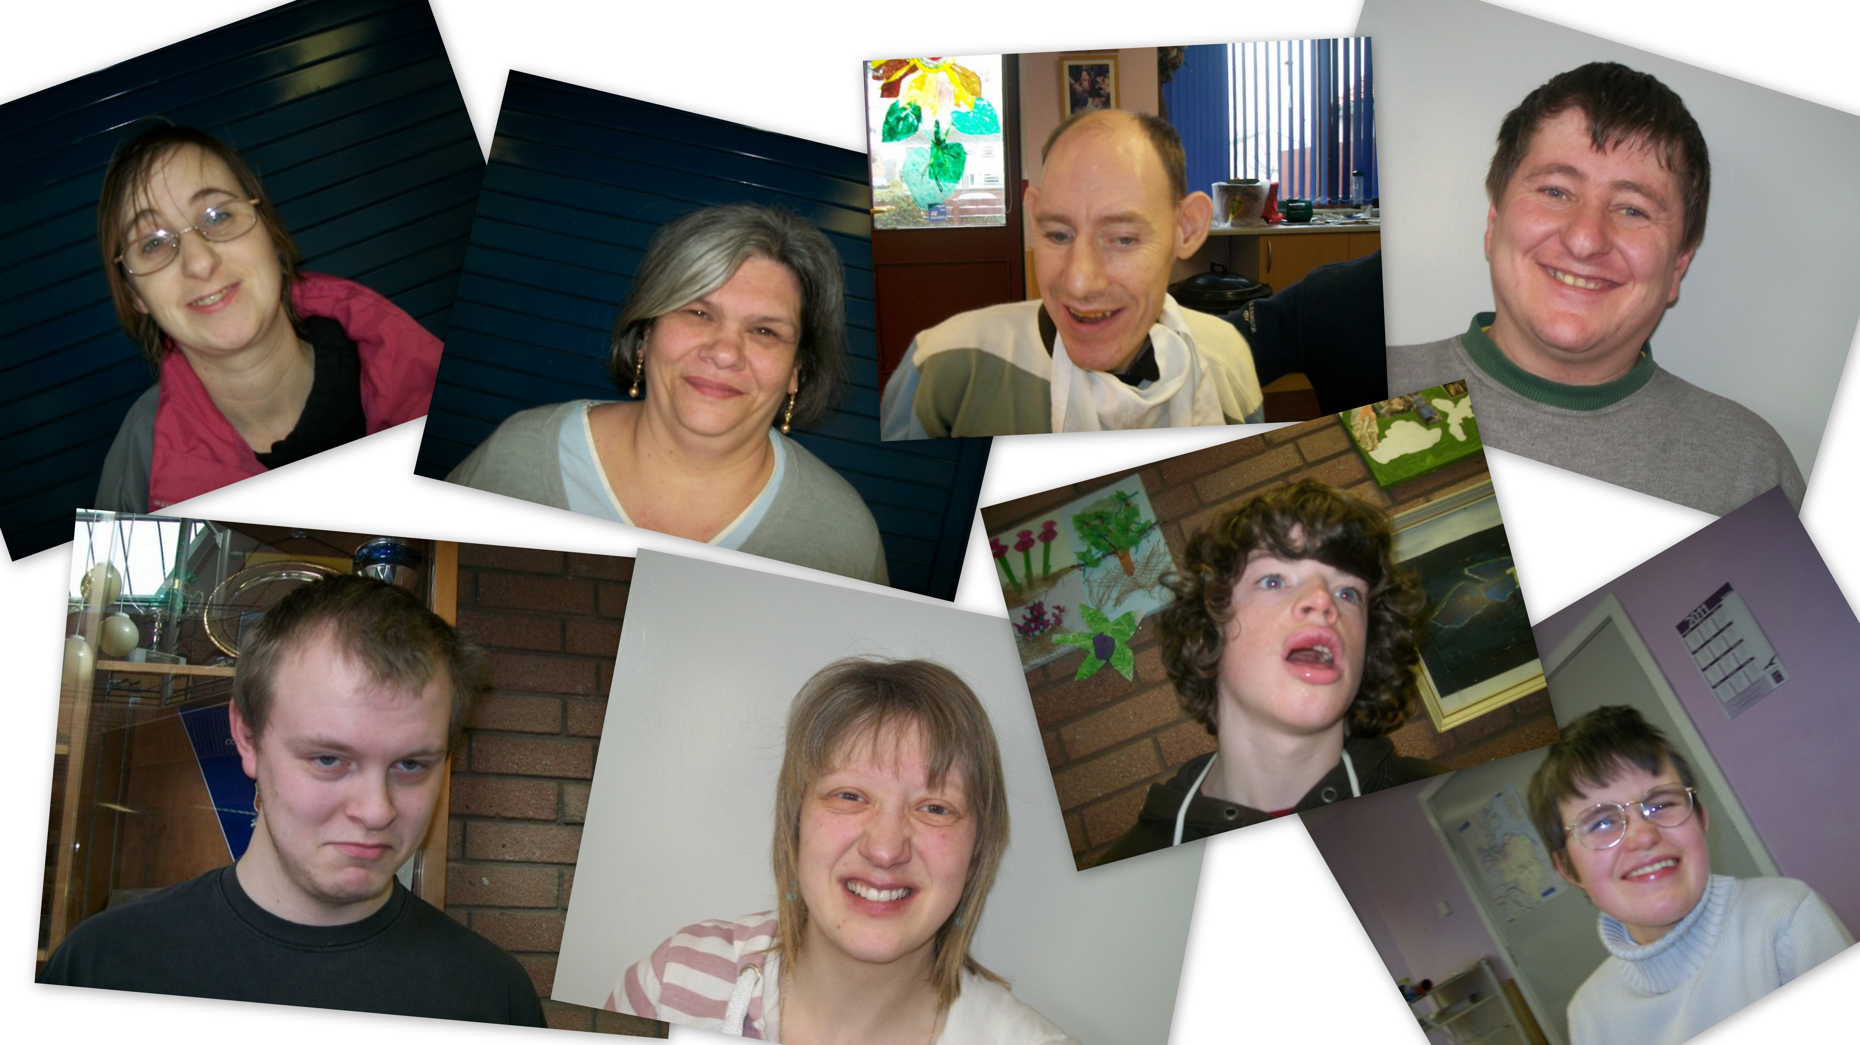
Our members council have a few ideas for the future. Assertiveness training and interview training has been requested so they can feel more confident and helpful and involved in their role. This should be arranged shortly. An annual conference is also being considered.
Port Seton Events

Port Seton’s Got Talent
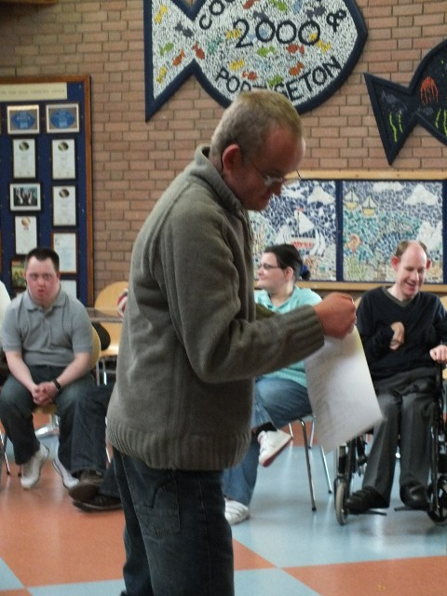
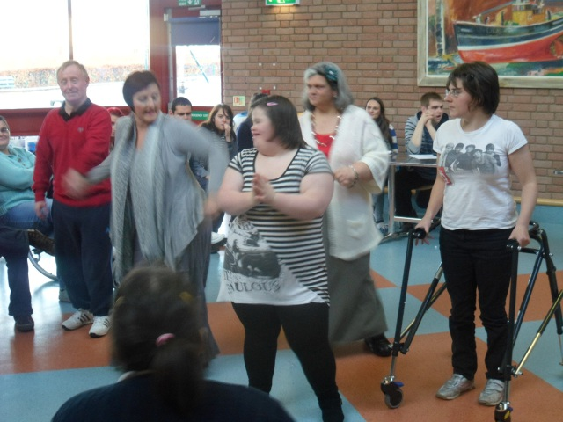
Due to popular demand, you know who you are, we held a Port Seton’s got Talent Competition in December. During the heats a few contestants trialled a couple of new songs and acts in preparation for the final. Well done the dancers. The final was videoed and should appear on the web site soon. DVD’s available. Congratulations to all who participated for a magnificent effort.

Christmas Party
Thanks Eddie for the brilliant music and sing-along at our Christmas Party. It’s a great time of year with everyone looking forward to the holidays and presents and in a happy mood.

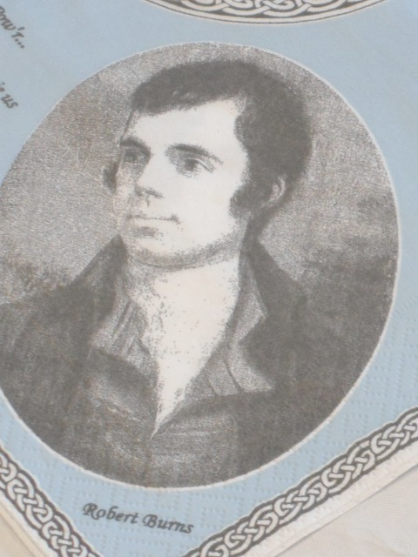
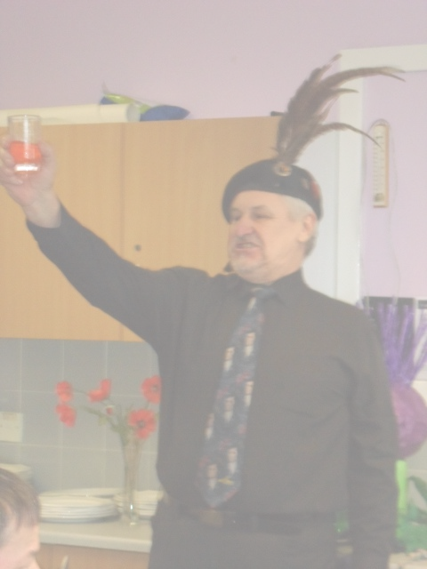
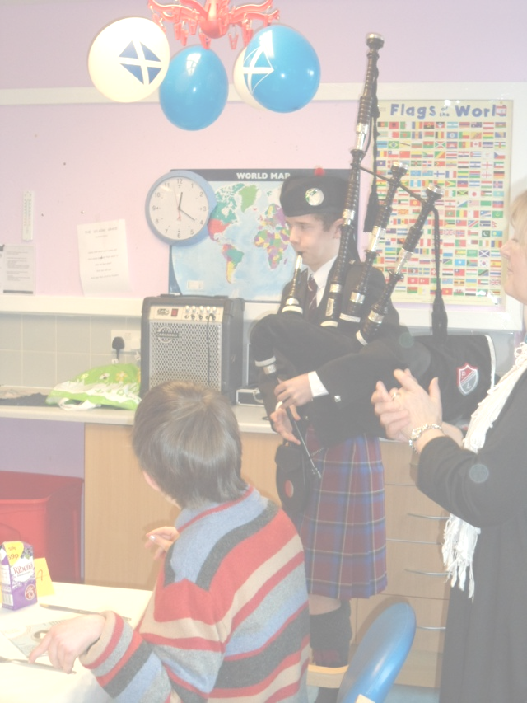
Burns Day
Party, Party, Party. Is that all we do? Thanks to Ian for his entertaining address to the Haggis and Ben from Preston Lodge in his Preston Lodge Tartan piping in the haggis. What a great start and it only got better. A big shout out also to all who got up and sang a song, said grace, or recited some poems. It really was a great occasion and I hope you all enjoyed it as much as me. As usual videos and web presence will be appearing shortly.


Staff News

Congratulations to Keira and David who now have a strapping wee lad in the house, Blake. Mother and baby well and both will visit the centre when able. Good effort as Darren would say.

We can all look forward to a replacement member of staff to cover Keira’s maternity leave starting here very soon. Lets all give him a warm and cheery welcome.

Congratulations also to Louise and Graham, getting married in May and off on honeymoon soon after. Looking forward to the pictures and maybe even a piece of cake that would go nice with a cup of tea. Yum.

Two members of staff are currently completing their HNC in Social Care by distance learning. Good luck to them.

The Thursday evening drop-ins held at Fisherrow Hub are now being staffed by the Port Seton Resource Centre team for now. The Musselburgh staff will take over from us later in the year.

Evelyn has retired her locum post and will be finishing in April.

Fixed Public Holidays:
Friday 29th March 2013 (Good Friday)
Monday 1st April 2013 (Easter Monday)
Friday 13th September 2013
Monday 16th September 2013

Contact Details:
Phone : 01875 818175
Email : cmaclean1@eastlothian.gov.uk

Transport Numbers:
07899877876 or 01875618651 or 01620827700
Important Diary Dates and Information

March 2013
Initial discussions are afoot with a view to arranging swimming/water polo/exercises in our local swimming pools. Nothing concrete so far (just as well in the pool) but watch this space.

Friday 26th April 2013
We are arranging a Spring Fling – Our Charity Fund Raiser Dance to be held at Port Seton Bowling Club from 7:30pm to 11:00pm. Tickets £10 and more info to follow.
Sat 1st June 2013
Open Day at the Centre 11:00 to 1:00
Come in and meet the staff for a wee informal visit and see what we have all been up to. Hopefully some work will be on display and if the weather is nice maybe a wee barbeque or bacon roll and tea.

Service User Conference
Once this idea from the Members Council has been firmed up with dates and purpose more work will be done.

Interview Training and Assertiveness Training
Our Members Council will receive assertiveness training between now and Easter. Interview training still to be arranged.

Carer Group
We would still like to encourage the formation of an active carers group along the lines of the existing carers group at Musselburgh hub. Could any willing and interested carers call Christine MacLean or Bruce Smith please.

Accessible Activities

A new leaflet will soon be available on accessible activities but in the meantime here is a list of currently available activities offered within a number of enjoyleisure sites across East Lothian. To blow our own trumpet for a second it should be noted that at P.S.R.C. we already have specialist coaches running three of our groups, namely, Swimming, Athletics and Zumba.

Meadowmill Sports Centre
Archery (Wed 10am-12pm)
Disability Athletics (Thur 10:30am-11:30am)

Musselburgh Sports Centre
Badminton (Tues 7pm-9pm)
Indoor Bowls (Sun 10:30am-12pm)
Multisports (Wed 6:30pm-8pm)
Low Impact Aqua Fit (Mon 1:30pm-2:15pm)

Fitness Fun (Mon 11:15am-12:15pm)
Fitness Fun (Wed 11:15am-12:15pm)
Zumba Gold (Wed 1:30pm-2:30pm)

Dunbar Leisure Pool
Boccia (Fri 3:30pm-4:30pm)

Loch Centre Tranent
Indoor Curling (Tues 10:30am-11:30am)

North Berwick Sports Centre
Zumba Gold (Seated) (Tues 9:45am-10:15am)
Zumba Gold (Seated) (Wed 3:00pm-3:30am)

Aubigny Sports Centre
More Fitness Fun (Tues 2:00pm-3:00pm) Starts April

